My Journey Toward Becoming a Web Security Professional

Name: Biniam Melku
Main Learning Platform: PortSwigger Web Security Academy
Projects: Flask Web Application and Web Application Firewall (WAF)

1. Introduction

Hello, my name is Biniam Melku. In this document, I want to share my progress as I work toward becoming a web security professional.

I use PortSwigger Web Security Academy as my main learning resource because it allows me to learn about web vulnerabilities and practice them through hands-on labs. My goal is to understand how these vulnerabilities work, how attackers exploit them, and how developers can prevent them.

Alongside my studies, I am developing a Flask-based web application and my own Web Application Firewall (WAF). I started these projects because I believe that learning how to build web applications will help me better understand how they become vulnerable and how to secure them.

I don't want to learn web security only from explanations and examples. I want to test what I learn, make mistakes, understand why something works or fails, and improve my skills through practice.

2. My Main Learning Method

LEARN → PRACTICE → FIX → DEFEND → DOCUMENT

My main learning method is to study one vulnerability at a time, practice it in my own web application, fix the weakness, test my WAF, and document what I have learned in notebook.

I follow five steps when studying a new vulnerability.

1. Learn the vulnerability

First, I study the vulnerability on PortSwigger Web Security Academy and work through the relevant labs. I try to understand how the attack works instead of simply memorizing the solution.

2. Practice what I learn

After understanding the vulnerability, I try to reproduce it in my own Flask application or an authorized lab. This helps me connect what I have learned with how web applications actually behave.

3. Fix the vulnerability

Once I understand how the attack works, I investigate why the application is vulnerable and implement an appropriate solution. I then test whether the fix addresses the underlying problem.

4. Test my WAF

Next, I test my Web Application Firewall against selected attack patterns to see whether it can detect or block them. I also look for weaknesses in my implementation and consider how to improve it.

5. Document my findings

Finally, I write notes about the techniques I learned, the challenges I faced, the solutions I tried, and the results I achieved. This helps me review what I have learned and identify areas where I need more practice.

I chose this method because I want to understand both sides of web security. I want to know how vulnerabilities are exploited and how applications can be protected against them.

---

3. My Progress in Web Security

3.1 SQL Injection

I started learning SQL injection through PortSwigger Web Security Academy labs. These exercises helped me understand how unsafe database queries can allow user input to interfere with SQL commands.

At first, I focused on the basic concepts and gradually explored more advanced techniques.

Basic Techniques I Have Learned

- Identifying SQL injection: Testing inputs to determine whether they affect the behavior of a database query.
- Using SQL syntax: Understanding how quotation marks and SQL operators can change query behavior.
- Conditional responses: Observing differences in application responses when SQL conditions evaluate to true or false.
- SQL comments: Learning how comments can affect the remaining parts of a query.
- Authentication bypass: Understanding how poorly constructed SQL queries can weaken login systems.

Additional Techniques I Have Studied next time

- UNION-based SQL injection
- Identifying column data types
- Blind SQL injection
- Time-based blind SQL injection
- Error-based SQL injection

Through these labs, I learned that SQL injection is not just about inserting special characters into an input field. The techniques that work depend on how the application handles input and how the database responds.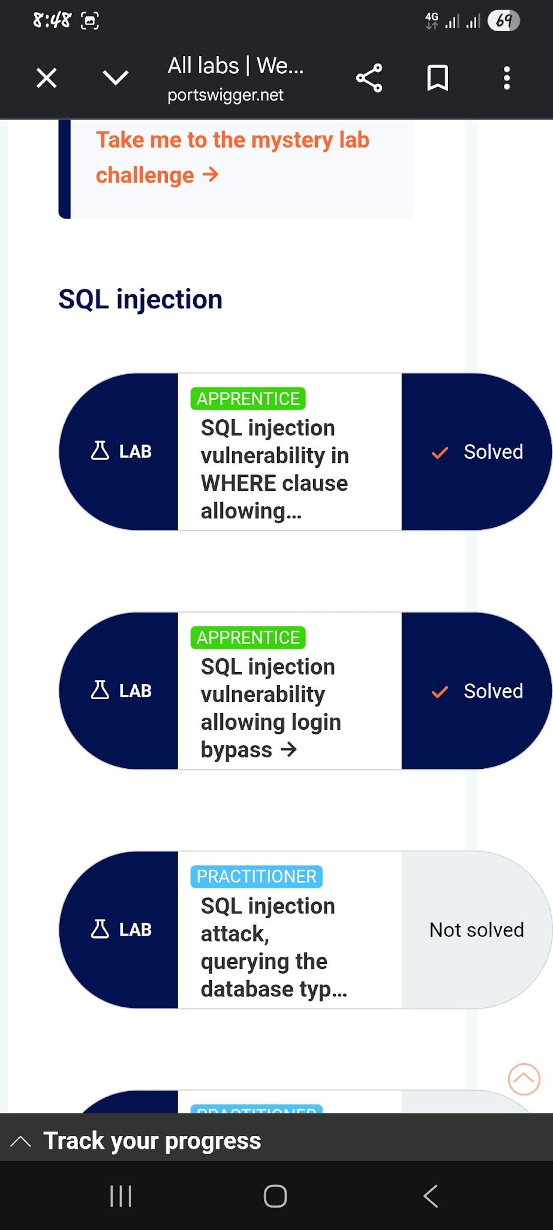

3.2 API Testing

API testing has been another important part of my learning journey. I have completed most of the API-related labs I have attempted on PortSwigger Web Security Academy.

These labs helped me understand how APIs work and how weaknesses in their implementation can expose sensitive information or allow unauthorized actions.

Main Techniques I Have Learned

Using API documentation

I learned how API documentation can help me understand available endpoints, request formats, parameters, and expected behavior. It also gives me a starting point when investigating an API.

Mass assignment

I studied how applications can become vulnerable when they automatically accept user-supplied fields that users should not be allowed to control.

Discovering unusual API endpoints

I practiced investigating API functionality that may not be directly visible through the normal application interface.

Other Concepts I Have Explored

- Understanding authentication and authorization in APIs.
- Identifying Broken Object Level Authorization (BOLA).
- Recognizing excessive data exposure in API responses.

These exercises have helped me understand that an API can function correctly while still having serious security weaknesses. Proper authentication, authorization, and input validation are essential for protecting API resources.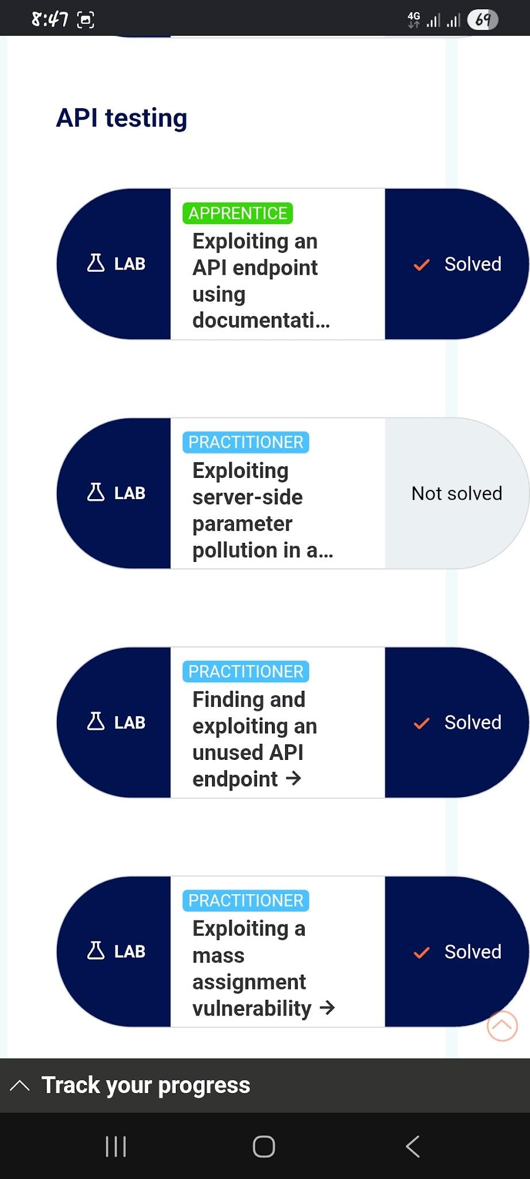

3.3 Authentication Vulnerabilities

Authentication is one of the topics I have spent time studying through PortSwigger Web Security Academy. I have completed labs covering several authentication weaknesses and learned different ways applications can unintentionally expose accounts to attackers.

Username Enumeration

I learned how an application may reveal whether a username exists, even when it is not supposed to disclose that information.

The techniques I studied include:

- Different response messages: Comparing error messages for valid and invalid usernames.
- Response differences: Observing changes in application behavior during login attempts.
- Wordlists: Using lists of possible usernames in authorized testing environments.
- Response timing: Investigating whether differences in processing time reveal information about account validity.

Two-Factor Authentication (2FA) Bypass

I practiced labs involving weaknesses in two-factor authentication. These exercises helped me understand how incomplete verification or mistakes in authentication workflows can allow additional security checks to be bypassed.

Password Reset Logic

I also studied password reset vulnerabilities and learned why account recovery processes must be designed carefully. Weaknesses in verification steps or password reset tokens can put user accounts at risk.

Other Authentication Concepts

- Brute-force protection and rate limiting.
- Authentication logic flaws.
- Session management.
- Secure password handling.
- Proper enforcement of multi-factor authentication.

From these labs, I learned that authentication security involves much more than checking a username and password. Every part of the login, session, and account recovery process must be implemented securely.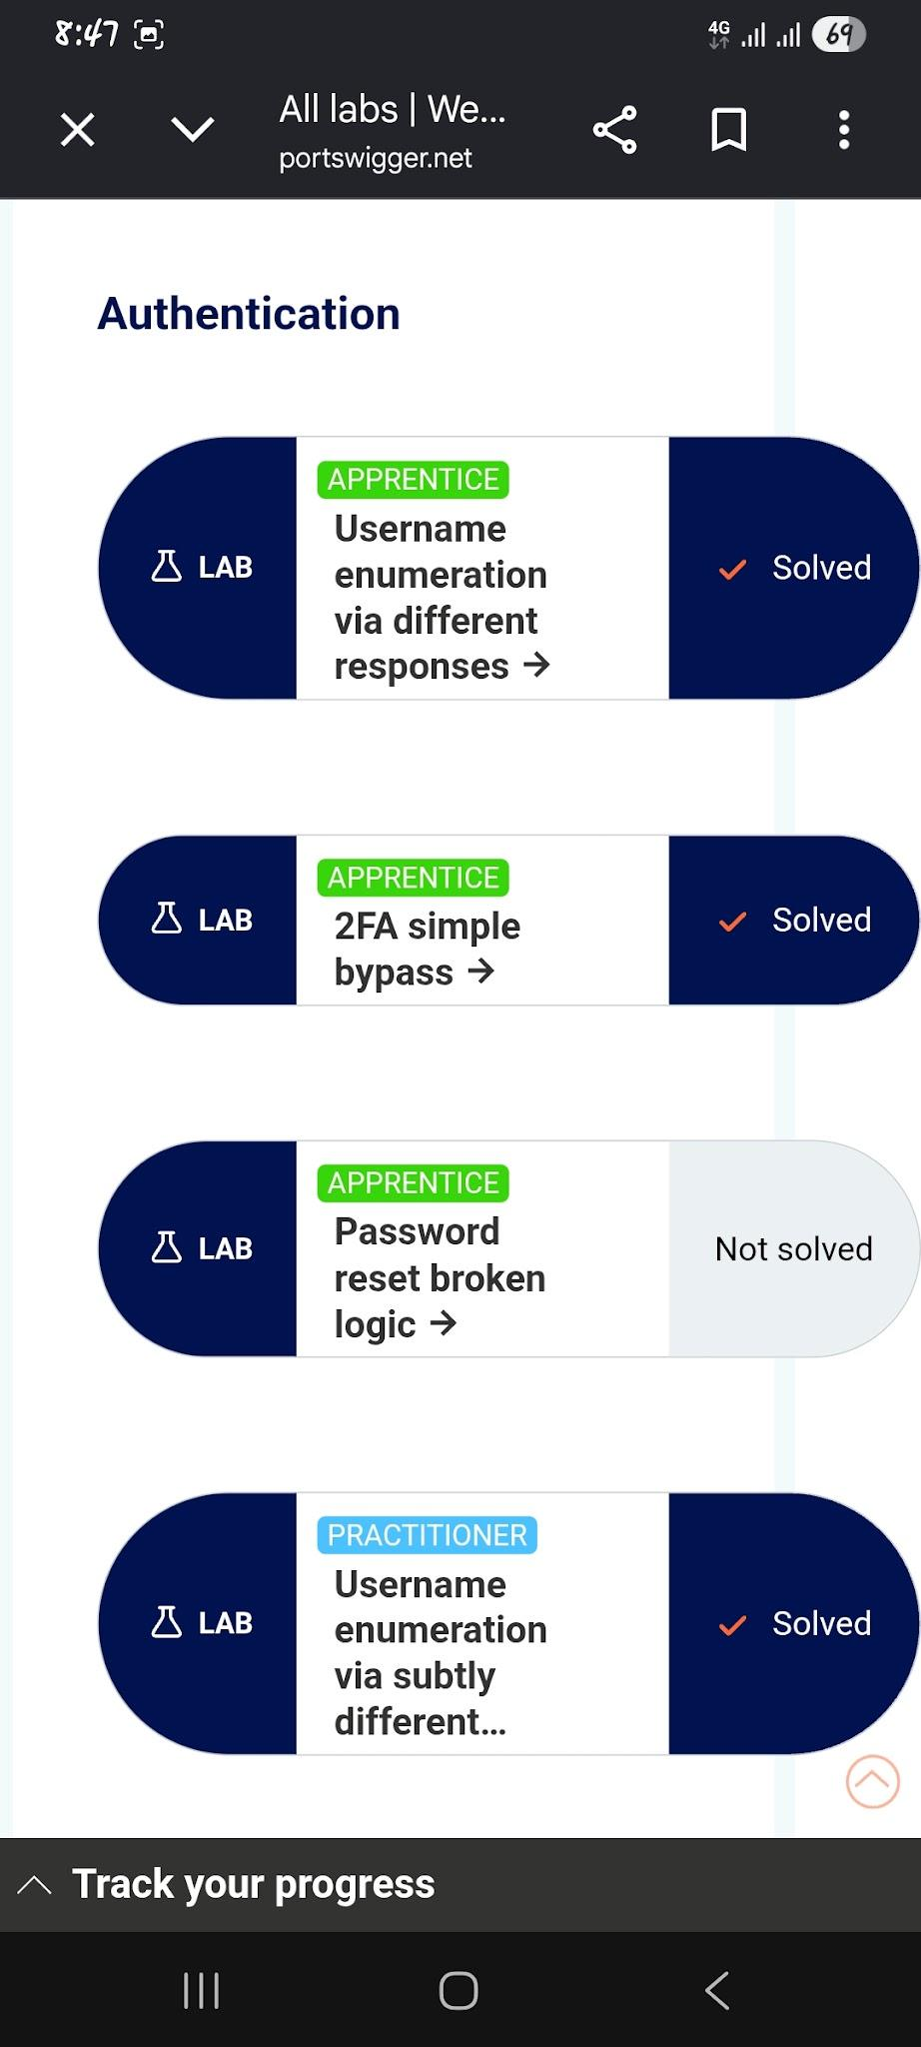

3.4 Path Traversal

I have completed all the Path Traversal labs on PortSwigger Web Security Academy.

These labs helped me understand how improper handling of file paths can allow an attacker to access files outside the intended directory.

Main Techniques I Have Learned

- Basic path traversal: Understanding how directory traversal sequences can be used to navigate outside an intended directory.
- Absolute fdile paths: Learning how absolute paths can affect attempts to restrict file access.
- URL encoding
- Nested traversal sequences
- Path normalization:
Completing these labs improved my understanding of how applications handle user-controlled file paths. I also learned that simply blocking suspicious strings is not always enough. Applications need proper path validation and strict restrictions on which files users are allowed to access.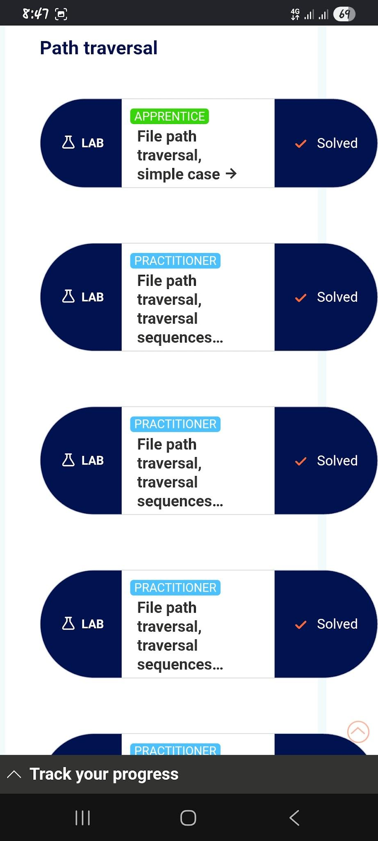

3.5 Access Control Vulnerabilities

Access control is another important topic in my learning journey. Through these labs, I learned how weaknesses in authorization can allow users to access resources or perform actions beyond their intended permissions.

There are two main types of privilege escalation I have studied.

Vertical privilege escalation happens when a user gains access to functionality intended for someone with higher privileges, such as an administrator.

Horizontal privilege escalation happens when a user accesses another user's information or resources without permission, even though both users have the same general level of access.

Main Techniques I Have Learned

User-controlled request parameters

I studied how modifying parameters in a request can sometimes allow users to access resources or functionality they should not be able to use.

Unprotected administrative functionality

I learned how administrative features can become accessible when an application does not properly check whether a user has the required permissions.

Additional Techniques and Concepts

- Insecure Direct Object References (IDOR)
- User role manipulation
- Multi-step process weaknesses
- URL-based access control

These labs helped me understand that hiding a button or restricting access through the user interface is not enough. The server must verify that every user has permission to perform each sensitive action.
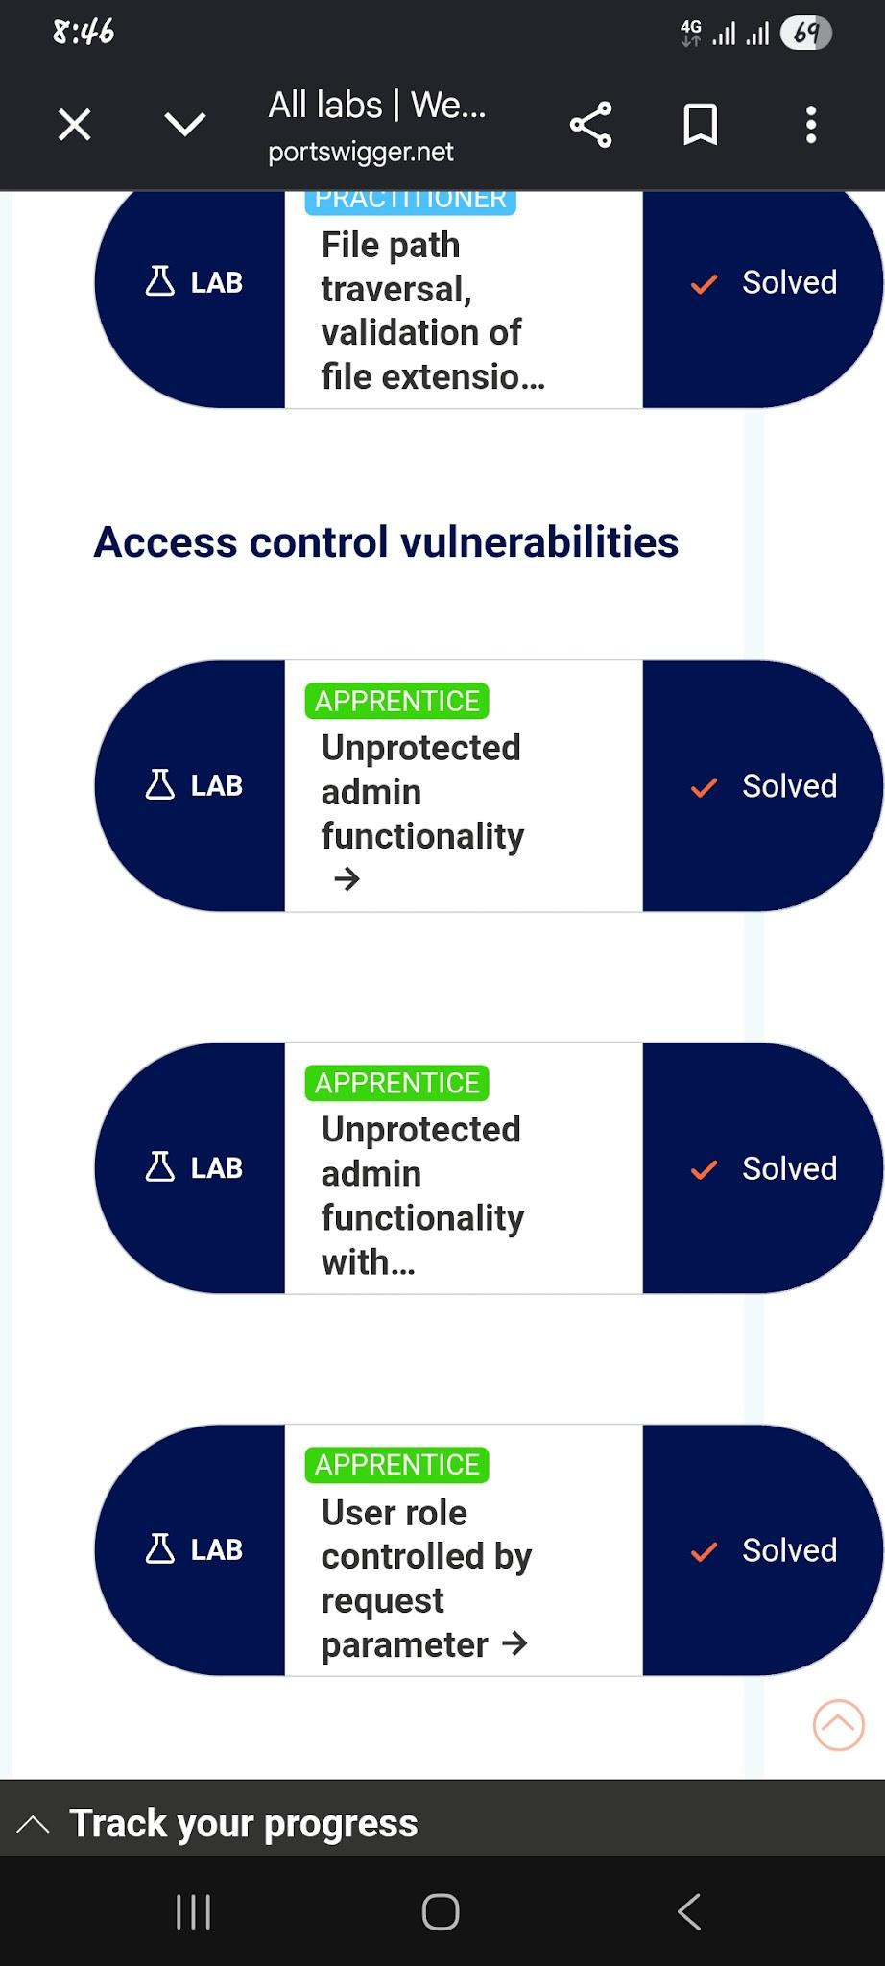

3.6 Business Logic Vulnerabilities

Business logic vulnerabilities occur when an application's design or implementation allows users to bypass rules or perform actions the developers did not intend.

Common Techniques and Examples
-Price manipulation
-Coupon abuse
-Race conditions
-Exploiting business rules
What I Learned

Business logic vulnerabilities taught me that an application can function normally while still allowing users to abuse its features. To identify these vulnerabilities, I need to understand the application's intended rules, test unusual workflows, and check whether the server enforces those rules correctly.
This concept is the topic am working it now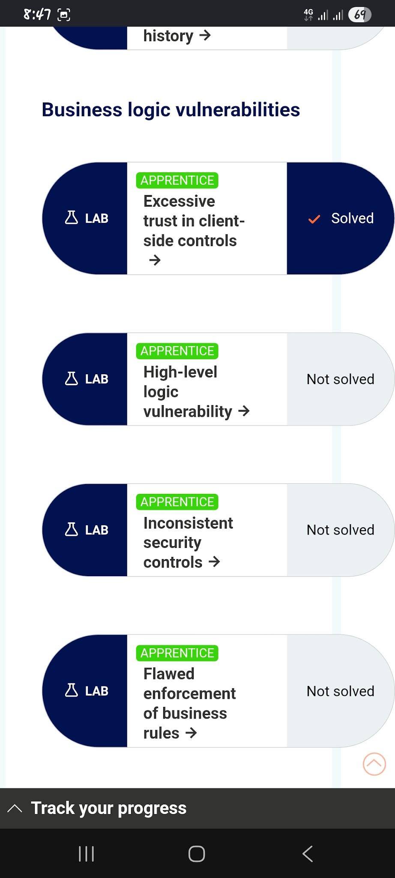
---
4. Tools I Used

During my web security learning journey, I used the following tools to practice identifying vulnerabilities, testing web applications, and improving security:

- PortSwigger Web Security Academy: Practiced web security vulnerabilities through hands-on labs.
- Burp Suite: Intercepted and modified HTTP requests to test web application security.
- Kali Linux: Used a Linux environment for cybersecurity learning and practical testing.
- Nmap: Scanned authorized targets to identify open ports and running services.
- Gobuster: Practiced discovering hidden directories and files on web servers.
- Wireshark: Explored network traffic and practiced analyzing packets.
- Netcat: Practiced basic network connections and communication.
- Python and Flask: Built and tested web applications to understand vulnerabilities and implement security protections.
- SQL and SQLite: Practiced database operations and explored SQL injection vulnerabilities.
- Browser Developer Tools: Inspected web pages, requests, responses, and client-side behavior.

I used these tools alongside hands-on labs and my own projects to develop practical web security skills.
5. My Practical Projects

5.1 Flask Web Application

Alongside my security studies, I am developing a web application using Flask. I want to use this project to put my knowledge into practice rather than keeping everything at the theoretical level.

When I study a vulnerability, I can investigate how it might occur in my application, examine the relevant code, and implement a suitable fix.

I plan to focus on areas such as authentication, database security, API endpoints, file handling, and access control.

As I learn more, I will continue improving the application and testing whether the security measures I implement work as expected.

5.2 Web Application Firewall (WAF)

I am also developing my own Web Application Firewall to learn more about defensive web security.

I use selected attack patterns from my studies to test whether my WAF can detect or block suspicious requests. I also want to understand its limitations and identify situations where it might block legitimate requests or fail to recognize an attack.

Building this project gives me an opportunity to explore how defensive mechanisms work and how they can be improved.

I understand that a WAF is only one layer of protection. It cannot replace secure coding, proper authorization, or fixing vulnerabilities in the application itself.

---

6. Capture The Flag (CTF) Practice

In addition to PortSwigger labs, I practice Capture The Flag challenges to improve my problem-solving skills and become more independent when investigating security problems.
Ctf website I use
picoCTF
OverTheWire
TryHackMe
Hack The Box
PortSwigger Web Security Academy

Some challenges require me to work through unfamiliar situations, gather information, test different ideas, and learn from unsuccessful attempts.

When solving a challenge, I try to understand why the solution works instead of simply copying commands from a walkthrough.

I also write notes about the challenge, the techniques I used, the difficulties I faced, and what I learned from solving it.

My goal is to become more confident in approaching unfamiliar security challenges and applying my knowledge without relying too heavily on external guidance.

---

7. Tracking My Learning Progress

I keep track of my learning by recording the vulnerabilities I study, the labs I complete, the techniques I learn, and the challenges I encounter.

For each topic, I want to document:

I also revisit difficult labs to check whether I truly understand the concepts or need more practice.

For me, progress is not just about completing more labs. It is about becoming better at understanding vulnerabilities, solving problems independently, and applying what I have learned.

8. Conclusion

My journey toward becoming a web security professional combines PortSwigger labs, Flask development, WAF testing, and CTF practice.

My main goal is to understand how vulnerabilities work, reproduce them safely, fix their underlying causes, and test my defenses. By following this learning method consistently, I hope to develop the practical skills needed to become a web security professional.

